# Chemical Reactions

# Many reactions occur in solution, especially in water (aqueous) solution. In solution, the molecules and ions are free to move about and interact. We will examine aqueous solutions to understand the behavior of ions in solution, to understand why some salts dissolve and others don’t, and to classify the types of reactions that occur in solution.

# General Properties of Aqueous Solutions

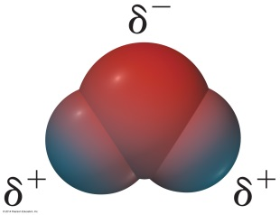A solution is a homogeneous mixture. A solution consists of a solvent, the substance in which something is dissolved, and one or more solutes, the substance(s) dissolved in the solvent. Solutions in which the solvent if water are called **aqueous solutions.**

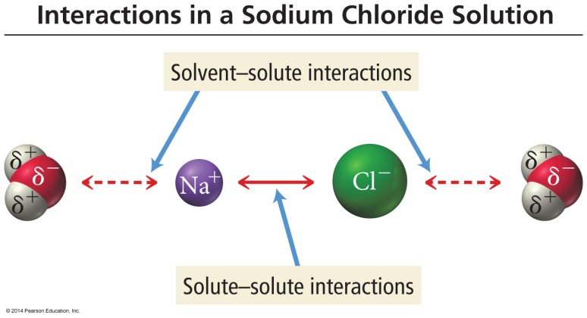When an ionic solid dissolves in water, the solid breaks up and the individual ions become surrounded by water molecules. Positive ions attract the negative (oxygen) end of the water molecule; negative ions attract the positive hydrogen end of the water molecule.

This process is called **solvation**. The solvated ions are free to move about in solution—and carry an electrical current. All aqueous solutions can be classified in terms of whether or not they conduct electricity.Solutes whose solutions conduct electricity are called **electrolytes**. (Solutions of electrolytes such as NaCl and HNO3(aq)contain ions and thus conduct electricity.)

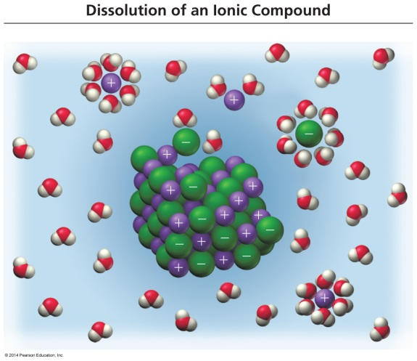

Solutions of nonelectrolytes such as sucrose (C12H22O11) and methanol (CH3OH) do not form ions in solution and thus do not conduct electricity.

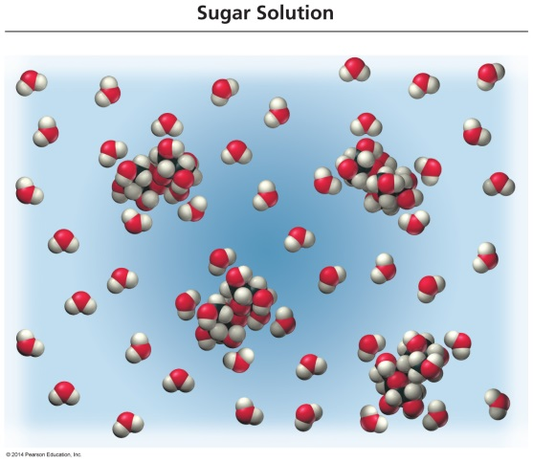

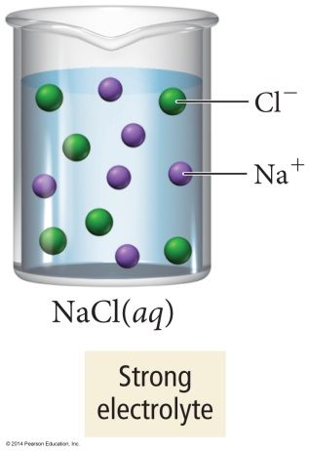

An electrolyte may be either a **strong electrolyte** or a **weak electrolyte**. A strong electrolyte exists in solution completely (or almost completely) as ions, while a weak electrolyte produces only a small concentration of ions when it dissolves in solution.

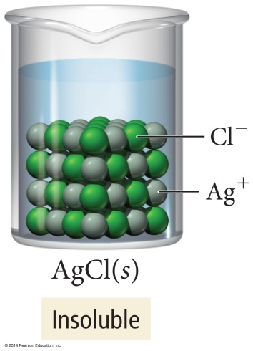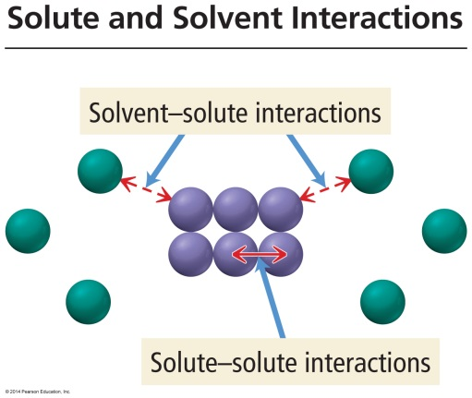Ionic compounds that are soluble in water **dissociate** completely and exist in solution entirely as ions. In solution, the solid no longer exists as a well-ordered arrangement of ions in contact with one another. Instead, each ion is surrounded by water molecules. This tends to stabilize the ions in solution and prevent cations and anions from recombining. Soluble ionic compounds are strong electrolytes. Not all ionic compounds dissolve in water; the interaction between the ions in the solid is too strong for water to break up. (Some solubility rules offer guidelines for determining the solubility of a salt.

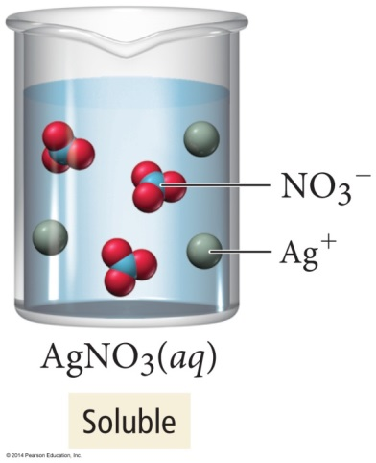

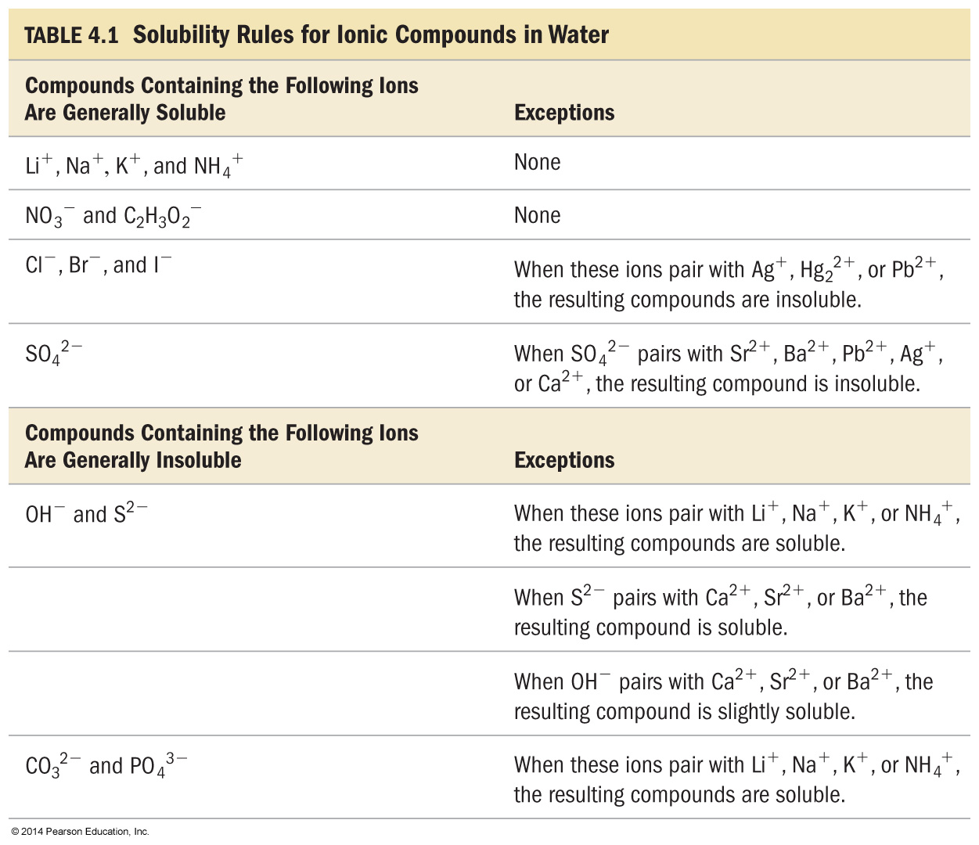

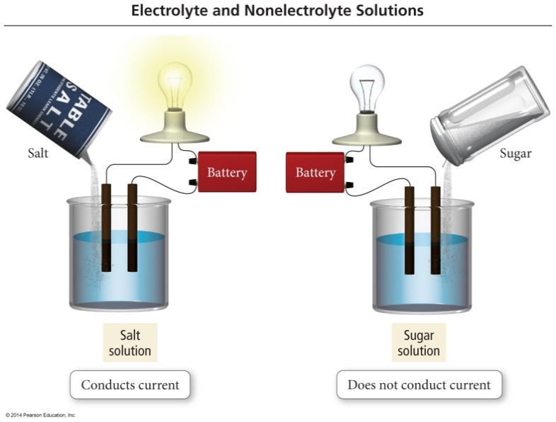Molecular compounds such as sugar and alcohol are nonelectrolytes. They have no tendency to come apart, and they exist in solution entirely as aqueous molecules.

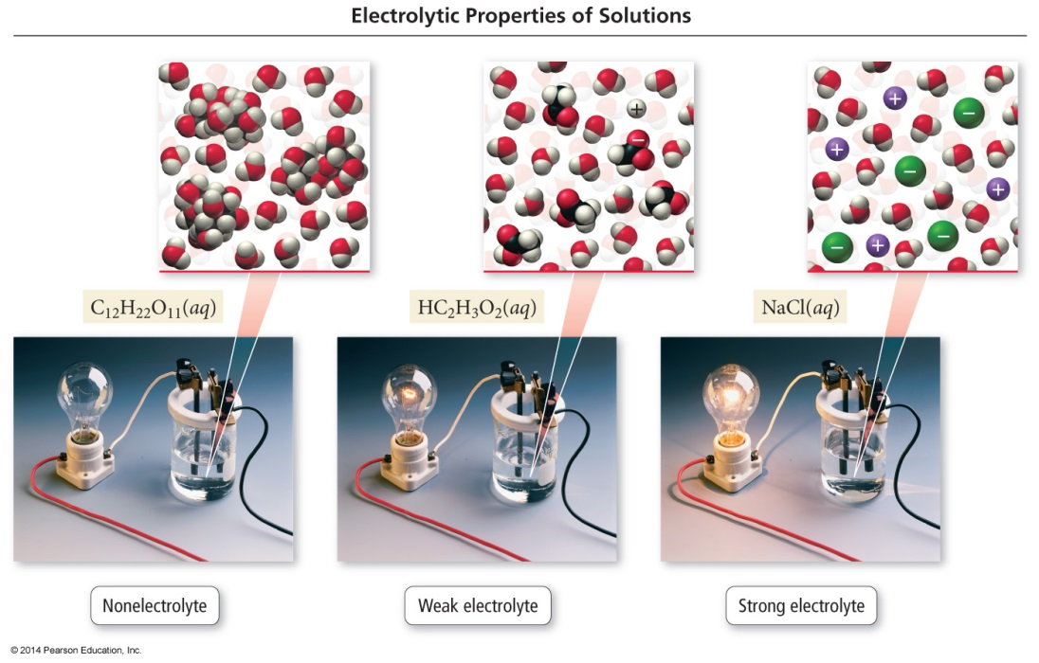

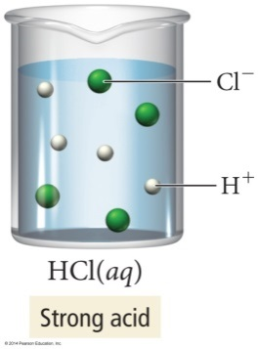Some molecular compounds, most notably acids and weak bases, are electrolytes.

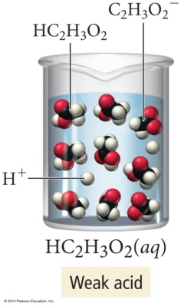S:\Wolf\ChemII\CSL\CentralScienceLive\Chapter04\Images\Image155.gifThe acids **HCl, HBr, HI, HNO3, HClO3, HClO4, and H2SO4**are molecular compounds that **ionize** in aqueous solution and exist completely as ions. For example, hydrogen chloride gas dissolves in water and ionizes in solution to give aqueous hydrogen ion and aqueous chloride ion.

All of the seven acids listed above are strong electrolytes. They are also called strong acids. In both instances the word *strong* denotes complete ionization. (Strong bases are ionic and are also strong electrolytes.)

# Organizing Aqueous Reactions (aka Double Replacement or Metathesis)

# One of the following must form:

# a precipitate a molecular compound or a gas

AX + BY AY + BX

# Precipitation Reactions

A **precipitation reaction** is one that occurs in solution and results in the formation of an insoluble product. In other words, two reactants may well be soluble, but the combination of the cation of one with the anion of the other is insoluble. For example, an aqueous solution of the soluble ionic compound, sodium sulfate, can be mixed with an aqueous solution of the soluble ionic compound, barium hydroxide. The result is the formation of a **precipitate**, the insoluble ionic compound barium sulfate.

S:\Wolf\ChemII\CSL\CentralScienceLive\Chapter04\Images\Image17.gif

Note that only one of the products of the reaction is a solid. Sodium hydroxide is soluble, and therefore aqueous.

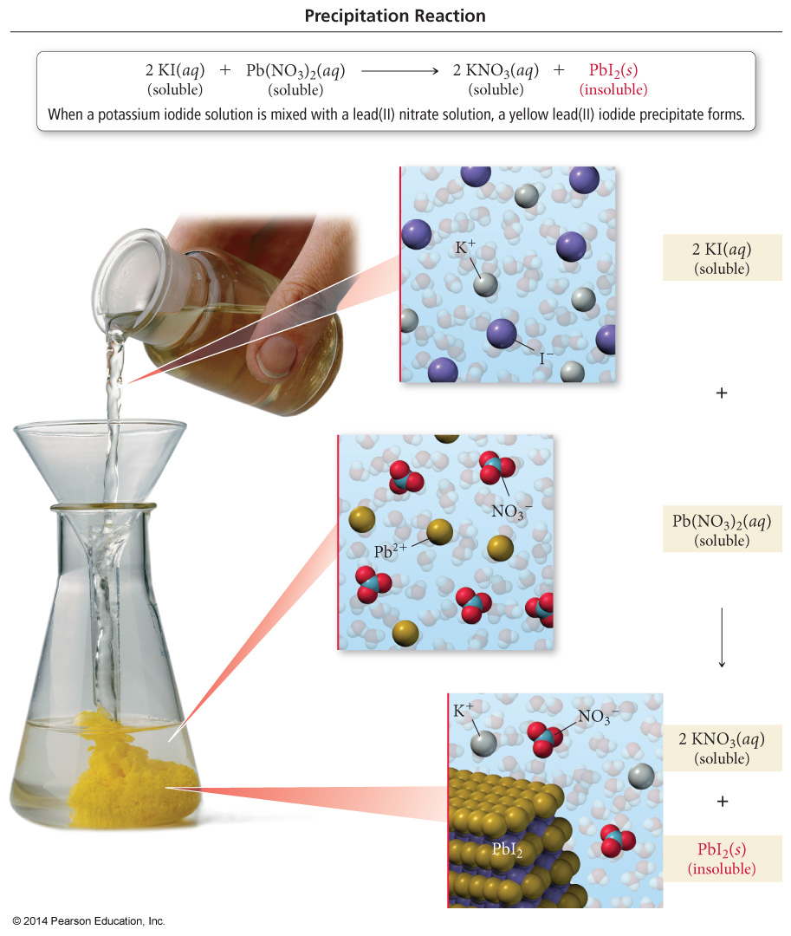

Whether or not an ionic product of a reaction in solution will precipitate from the solution can be predicted using a set of solubility guidelines.

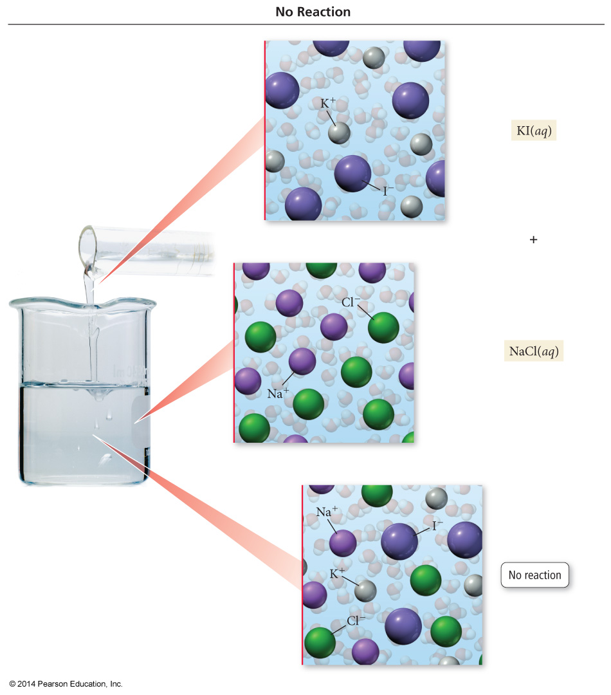

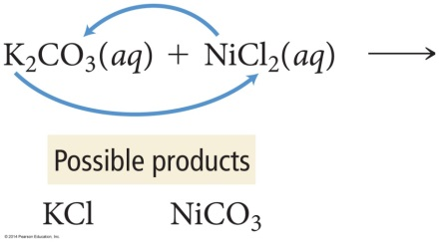

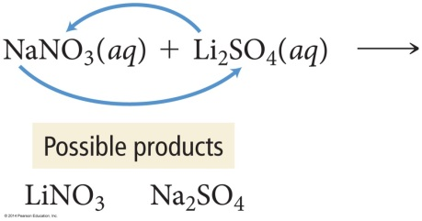

It is useful to write **net-ionic equations** for reactions in aqueous solution because these equations present the essential process. Consider for example the reaction below:

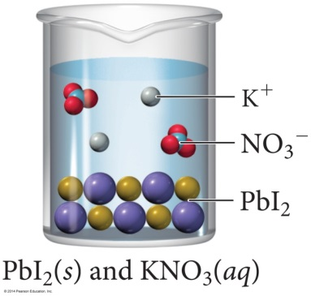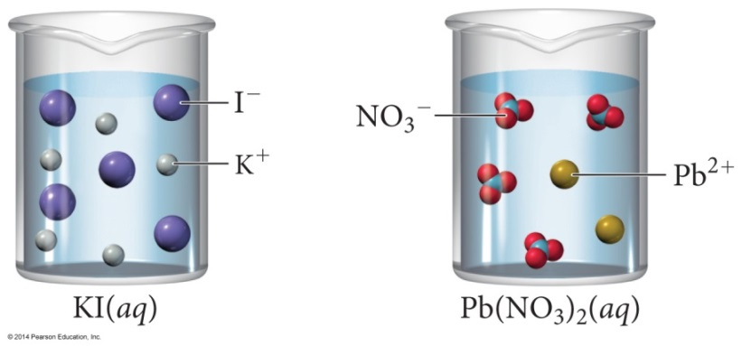

2 KI(aq) + Pb(NO3)2(aq) PbI2(s) + 2 KNO3(aq)

The potassium iodide, lead (II) nitrate, and potassium nitrate are all salts; they exist in solutions completely ionized:

2 K1+(aq) + 2 I1-(aq) + Pb2+(aq) + 2 NO31-(aq) PbI2(s) + 2 K1+(aq) + 2 NO31-(aq)

This type of equation is called the **complete ionic** or **detailed ionic equation**. Notice that nothing happens to the potassium ion in this reaction; likewise, nothing happens to the nitrate ion. They are not involved in the reaction and are called **spectator ions**. If these spectator ions are cancelled from both sides, the net-ionic equation results:

2 I1-(aq) + Pb2+(aq) PbI2(s)

The net ionic equation more clearly illustrates what is happening in the reaction. In this case, the lead (II) ions [from any soluble salt] combine with the iodide ions [from any soluble salt] to produce the insoluble silver chloride.

# Acids and Bases

Acids and bases are two important classes of compounds. An **acid** is a molecular substance that ionizes to form a hydrogen ion (H+) and increases the concentration of aqueous H+ ions when it is dissolved in water. Because a hydrogen atom consists of a proton and an electron, H+ is simply a proton; therefore, an acid can also be thought of as a substance that can donate a proton. Hydrogen chloride ionizes in water, increasing the aqueous concentration of H+.

HCl(aq) H+(aq) + Cl1-(aq)

Strong acids are those that ionize completely in water. Strong acids are also strong electrolytes. Weak acids are those that ionize partially in water. Weak acids are also weak electrolytes. Acetic acid is an example of a weak acid.

An acid may produce more than one hydrogen ion per molecule, in which case it is called a **polyprotic** **acid**. An example is sulfuric acid (a diprotic acid):

H2SO4(aq) H+(aq) + HSO41-(aq) complete ionization

HSO41-(aq) H+(aq) + SO42-(aq) only partialionization

Loss of the first hydrogen ion is virtually complete. So sulfuric acid is classified as strong. The second hydrogen is more difficult to remove and the bisulfate ion is only partially ionized. The bisulfate ion is a weak acid.

A **base** is a substance that increases the concentration of aqueous OH– ions when it is dissolved in water. Bases can be either ionic or molecular substances. A base can be thought of as a substance that can accept a proton; in other words, bases are substances that react with H+ ions. A strong base is an ionic compound that dissociates completely in water. Group 1A hydroxides, such as sodium hydroxide, and heavy Group 2A hydroxides, such as calcium hydroxide, are strong bases.

NaOH(aq) Na+(aq) + OH1-(aq)

Ammonia, NH3, is a **weak base**. It produces a relatively low concentration of hydroxide ions in solution (most ammonia in solution remains as NH3):

NH3(aq)+ H2O(l)  NH4+(aq) + OH1-(aq)

# Reactions of Acids and Bases (forming a molecule, H2O)

An acid and a base can react with one another to form a molecular compound and a **salt**. The combination of hydrochloric acid and sodium hydroxide is a familiar neutralization reaction.

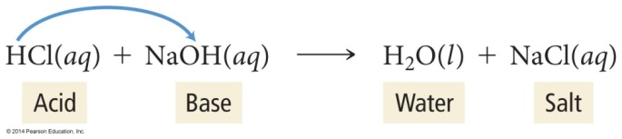

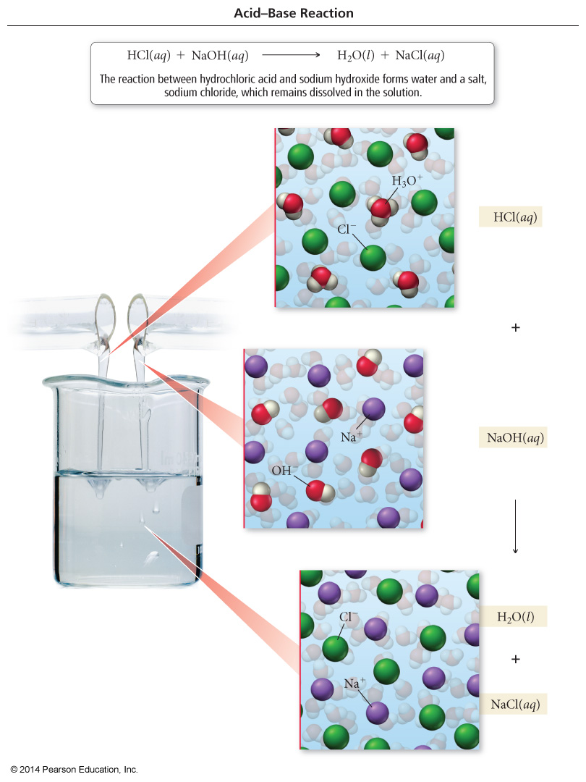

The molecular compound produced by the reaction is water, and the salt is sodium chloride. The anion (Cl1-) of the salt comes from the acid, and the cation (Na1+) of the salt comes from the base. Both hydrochloric acid and sodium hydroxide are strong electrolytes so the detailed ionic equation for the neutralization reaction is:

H1+(aq) + Cl1-(aq) + Na1+(aq) + OH1-(aq)  H2O(l) + Na1+(aq) + Cl1-(aq)

When the spectator ions are deleted, the net ionic equation becomes:

H1+(aq) OH1-(aq)  H2O(l)

This is the net ionic equation for the neutralization of **any** strong acid by any strong base. The only change when the acid or base is different is the salt that is formed in the reaction.

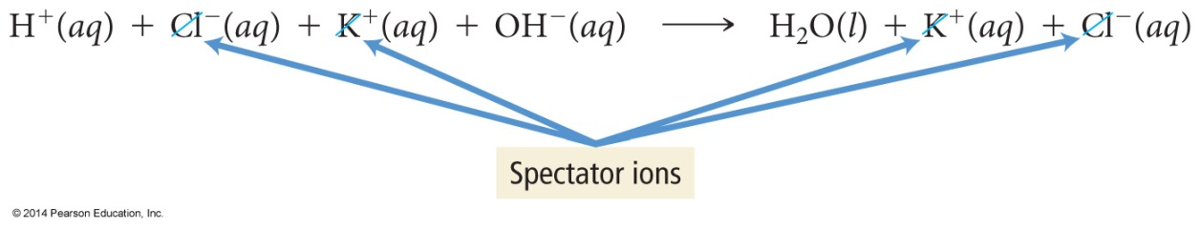

Weak acids and weak bases also undergo neutralization reactions. The difference is that, being weak electrolytes, the acids or bases exist predominately in the molecular form. For example, consider the reaction of ammonia (a weak base) with nitric acid (a strong acid):

HNO3(aq) + NH3(aq)  NH4NO3(aq) OVERALL

H1+(aq) + NO31-(aq) + NH3(aq) NH41+(aq) + NO31-(aq) DETAILED

H1+(aq) + NH3(aq) NH41+(aq) NET-IONIC

# Gas-forming Reactions

* + - **Carbonic Acid** spontaneously decomposes into carbon dioxide and water **H2CO3(aq) CO2(g) + H2O(l)**

H2SO4(aq) + Na2CO3(s) H2CO3(aq) + Na2SO4(aq)

H2SO4(aq) + Na2CO3(s) CO2(g) + H2O(l) + Na2SO4(aq)

* + - **Sulfurous Acid** spontaneously decomposes into sulfur dioxide and water

**H2SO3(aq)  SO2(g) + H2O(l)**

* + - **Ammonium Oxide** and **Ammonium Hydroxide** spontaneously decomposes into ammonia and water

**(NH4)2O(aq) NH3(g) + H2O(l)**

**NH4OH(aq) NH3(g) + H2O(l)**

* + - Additionally the production of a **volatile binary acid**. These acids are in the gas phase and bubble out of the solution. **H2S(g)** and **HCl(g)**are common examples.

S:\Wolf\ChemII\CSL\CentralScienceLive\Chapter04\Images\Image25.gif

# Oxidation-Reduction Reactions (Synthesis, Decomposition and Single Replacement Reactions)

In addition to precipitation and neutralization reactions, aqueous ions can participate in **oxidation-reduction reactions**. Oxidation-reduction reactions involve the transfer of electrons from one chemical species to another. When magnesium burns, it combines with oxygen to form magnesium oxide. This is a process called **oxidation**. If a metal oxide or sulfide ore is heated with carbon, it is converted into the metal. In this case the metal is said to be reduced. These are examples of a huge class of reactions called oxidation and reduction reactions, or **redox reactions**.

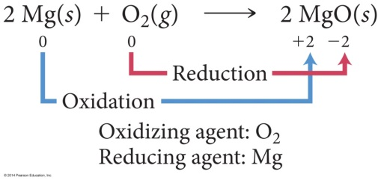

In every redox reaction, some substance is oxidized and another substance reduced. One cannot occur without the other. The substance that is reduced is by definition the substance that oxidizes the other—it is called the **oxidizing agent**. Likewise, the substance that is oxidized must reduce the other substance—it is called the **reducing agent**.

However, not all redox reactions involve oxygen. What is common to all redox reactions is a transfer of electrons between substances.

**Reduction—**the addition of electron(s)

**Oxidation**—the removal or loss of electron(s)

**Reducing agent—**supplies electrons

**Oxidizing agent—**removes electrons

An element whose oxidation number ***decreases*** (***gains*** electrons) during the reaction is ***REDUCED***.

If the oxidation number ***increases*** (***loses*** electrons) it is ***OXIDIZED***.

**LEO the lion**

**says GER**

e-

### X

Transfer or shift of electrons



### Y

|  |  |
| --- | --- |
| X loses electron(s) | Y gains electron(s) |
| X is oxidized | Y is reduced |
| X is the reducing agent | Y is the oxidizing agent |
| X increases in oxidation number | Y decreases in oxidation number |



**OIL RIG**

A piece of calcium metal, for example, dissolves in aqueous acid.

S:\Wolf\ChemII\CSL\CentralScienceLive\Chapter04\Images\Image26.gif

Electrons from the calcium metal have been transferred to the hydrogen ions. The calcium has undergone **oxidation** (loss of electrons), and the hydrogen ion has undergone **reduction**(gain of electrons).

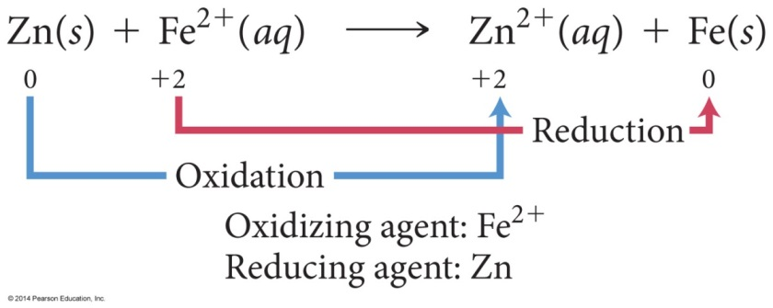

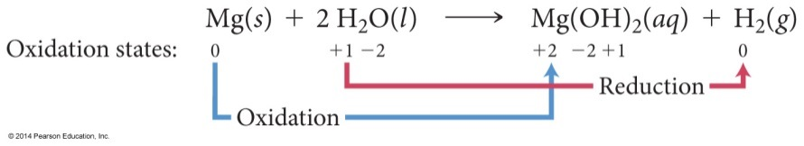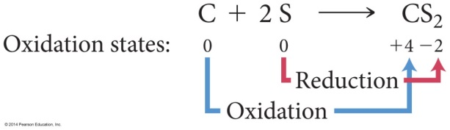When a substance loses electrons (when it is oxidized), the charge becomes more positive between reactants and products. When a substance gains electrons (when it is reduced), the charge of the substance decreases between the reactants and products.

Example: Identify the oxidizing and reducing agent.

2 Al(s) + 3 H2SO4(aq) Al2(SO4)3(aq) + 3 H2(g)

2 Al(s) + 3 H2SO4(aq) Al2(SO4)3(aq) + 3 H2(g)

+3 -2 0

0 +1 -2

+6

+6

The oxidation number of Al ***increased*** from ***0 to +3*** (Al lost electrons), so Al was ***oxidized*** and is therefore the ***reducing*** agent.

The oxidation number of H ***decreased***from ***+1 to 0*** (H gained electrons), so H was ***reduced***. H2SO4 is the ***oxidizing*** agent.

Example: Identify the oxidizing and reducing agent.

PbO(s) + CO(g) Pb(s) CO2(g)

PbO(s) + CO(g) Pb(s) CO2(g)

+2 +2 0 +4

-2 -2 -2

Pb was ***reduced*** (from +2 to 0) PbO is the ***oxidizing*** agent.

C was ***oxidized*** (from +2 to +4) CO is the ***reducing*** agent.

Example: Identify the oxidizing and reducing agent.

2 H2(g) + O2(g) 2 H2O(g)

2 H2(g) + O2(g) 2 H2O(g)

0 0 +1 -2

O was ***reduced*** (from 0 to –2); O2 is the ***oxidizing*** agent

H was ***oxidized*** (from 0 to +1); H2 is the ***reducing*** agent.

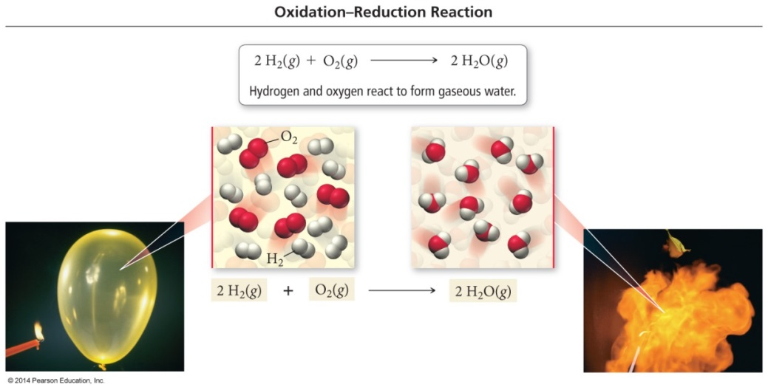

In order to determine whether a reaction is an oxidation-reduction reaction, we compare the **oxidation numbers** (or oxidation states) of each element on both sides of the equation. Oxidation numbers can be assigned using the following rules.

|  |
| --- |
| **1. Any atom in its elemental form has an oxidation state of zero. No exceptions.**  **2. Any monatomic ion has an oxidation state equal to its charge. No exceptions.**  **3. Oxygen almost always has an oxidation state of - 2.**  **Exceptions include the peroxide ion (O22–) in which its oxidation state is - 1,**  **4. Hydrogen almost always has an oxidation state of +1.**  **Exceptions include metal hydrides (such as NaH) in which its oxidation state is -1.**  **5. Fluorine (as an ion) always has an oxidation state of – 1. No exceptions.**  **6. The other halogens *usually* have oxidation states of -1 also.**  **Exceptions are when they are combined with fluorine or oxygen. In these cases the halogens (other than fluorine) can have positive oxidation states.**  **6. The sum of oxidation states must equal the overall charge on the species; i.e., the sum of oxidation states in a molecule must equal zero, and the sum of oxidation states in a polyatomic ion must equal the charge on the polyatomic ion.** |

Whether or not such a reaction will occur can be predicted using the **activity series.**

***The more reactive element must be bonded.***

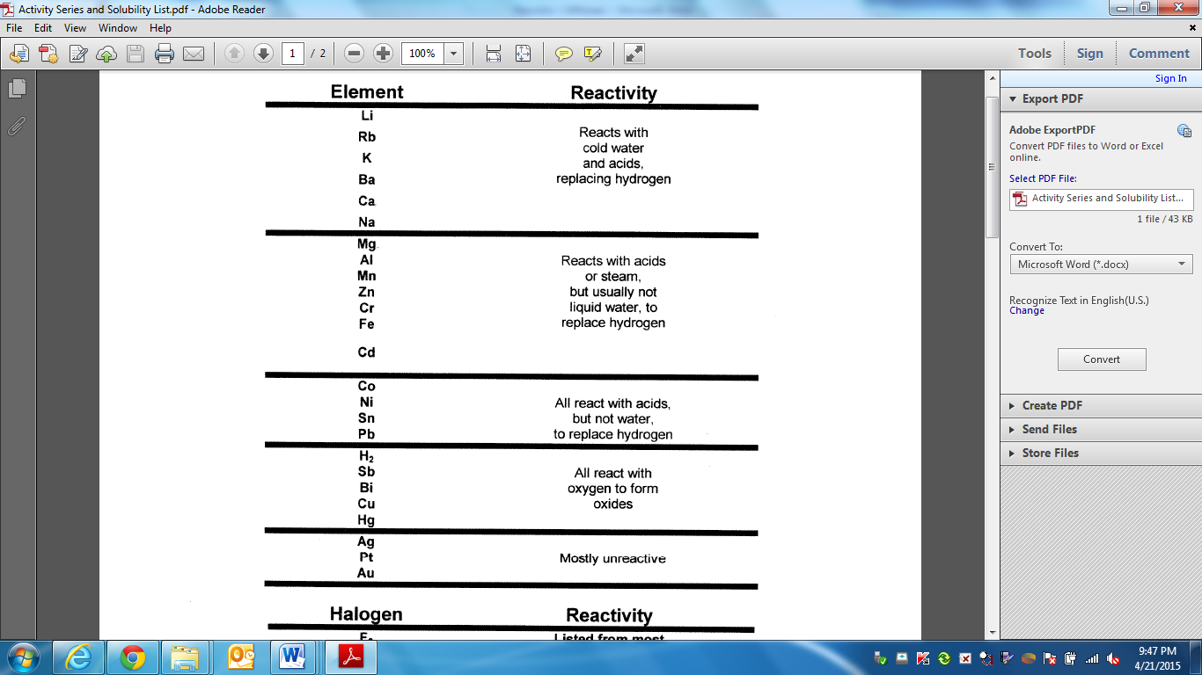

**NOBLE**

**METALS**

**ACTIVE**

**METALS**

